CREATIVE EDUCATIONAL SERVICES
BEGINNING OF TERM II EXAMINATION 2024
P.3 RELIGIOUS EDUCATION
2 HOURS 15 MINUTES

Name ________________________________________ Stream ____________
Campus: _________________________________________________________

DO NOT OPEN THIS BOOKLET UNTIL YOU ARE TOLD TO DO SO.

Read the following instructions carefully.

- Read the questions carefully before answering
A
B
For Examiner’s use only
TOT
any question.

- Answer all questions in the space provided.

- Write well. Unnecessary crossing of work will lead to loss of marks.

- Wrong spellings will lead to loss of marks.

- Any handwriting that cannot be read may lead to loss of marks.

- Who was the mother of Jesus?
_______________________________________________________________
- Name these things which God created.
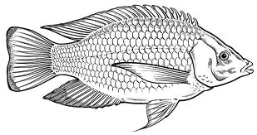 |  | 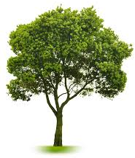

- Circle three members of God’s family.
Priests, thieves, Christians, children.

- On which day do Christians go for general prayers?
_______________________________________________________________
- Why did God create these things?
- lakes _______________________________________________________
- plants _______________________________________________________
- hens ________________________________________________________
- Give any one use of water to people.
________________________________________________________________
- Who was the first woman to be created?
________________________________________________________________
- Mention the animals which God created to give us;
- milk _________________________________________________________
- eggs_________________________________________________________

- Draw these places of worship.
church | mosque

- How can you care for a friend?
___________________________________________________________
- Name the people who do this work at school.
- teaching _______________________________________________
- cooking ________________________________________________
- (a) Name these gifts of the parts of the body.
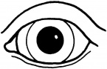 | 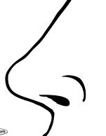 | 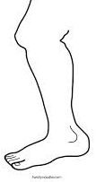

(b) Why did God give you
(i) the eyes ________________________________________________
(ii) the legs __________________________________________________

- Write down any two gifts created to give us light.
- ____________________________ (ii) _________________________

- Name these needs of people.
 | 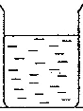 | 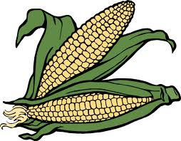

- Give the roles of these people at home.
- mother ___________________________________________________
- children __________________________________________________
- Match names to their meaning.
Kirabo God is with us
Peter Joy
Emmanuel gift
Ssanyu rock

- Who is the only son of Jesus?
____________________________________________________________
- Name the holy book for Christians.
____________________________________________________________
- Name any two disciples of Jesus
- ___________________________________________________________
- ___________________________________________________________

- Give one way in which Christians talk to God.
____________________________________________________________
- Name these things used to keep the body clean.
 | 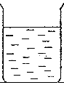 | 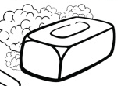

- Tick three ways in which the people in the Bible meet their needs
- by praying
- by sleeping
- by working hard
- by sharing
- Mention two ways of caring for a baby.
(i) ____________________________ (ii) _________________________
- Name this Christian symbol.

______________________________________________

